THE EFFECTIVENESS OF TEACHING VOCABULARY USING HYPONYMY GAMES AT SMPN 4 SIMPANG KATIS
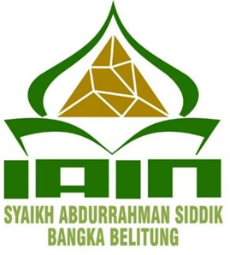

A THESIS
Submitted to the Undergraduate Program in Partial Fulfilment of the Requirements for Bachelor Degree Education (S.Pd)
By
Wulan Dariah
2113040

TARBIYAH FACULTTY
ENGLISH EDUCATION STUDY PROGRAM
STATE INSTITUTE OF ISLAMIC STUDIES
SYAIKH ABDURRAHMAN SIDDIK
BANGKA BELIT UNG
2025

Surat Keterangan Plagiasi
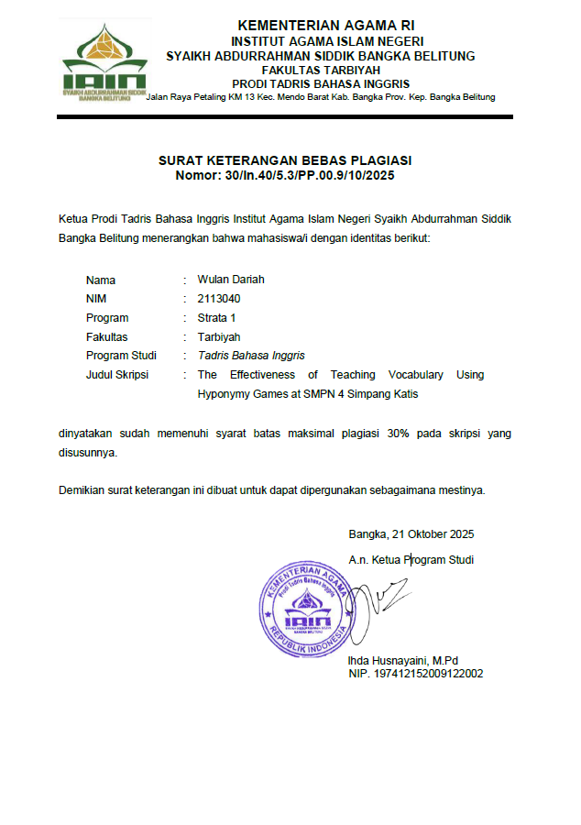

LETTER OF DECLARATION
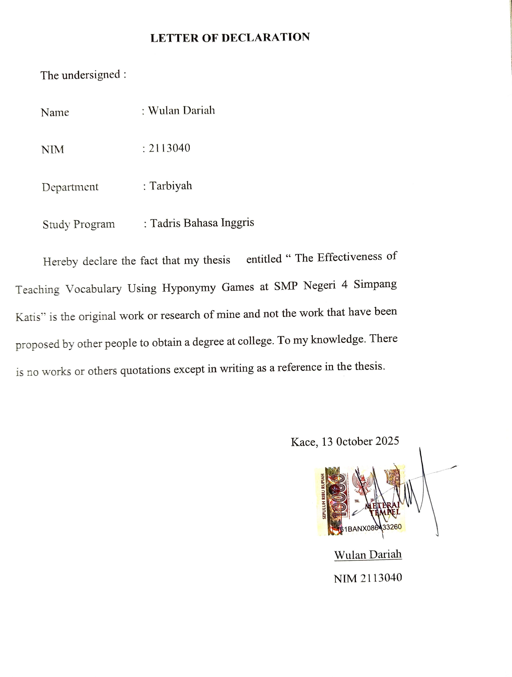

OFFICIAL MEMO OF ADVISORS

THE EFFECTIVENESS OF TEACHING VOCABULARY USING HYPONYMY GAMES AT SMPN 4 SIMPANG KATIS

A Thesis by
Wulan Dariah
2113040
English Education Study Program
Tarbiyah Department

TARBIYAH
IAIN SYAIKH ABDURRAHMAN SIDDIK
BANGKA BELITUNG
2025
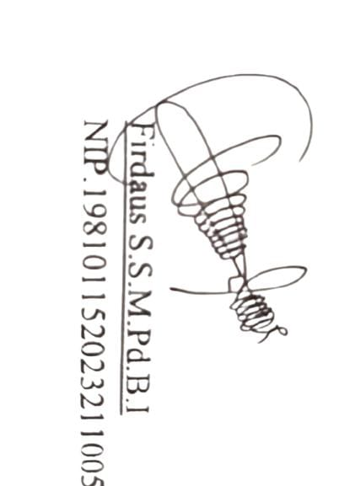
Approved by
Kace, 13 October 2025
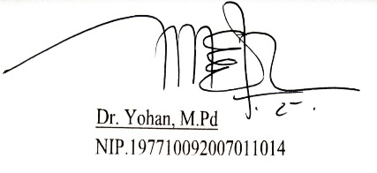
Advisor I Advisor II

OFFICIAL MEMO OF ADVISORS

THE EFFECTIVENESS OF TEACHING VOCABULARY USING HYPONYMY GAMES AT SMPN 4 SIMPANG KATIS

A Thesis by
Wulan Dariah
2113040
English Education Study Program
Tarbiyah Department

TARBIYAH
IAIN SYAIKH ABDURRAHMAN SIDDIK
BANGKA BELITUNG
2025
Approved by
Kace, 12 November 2025
Examiner I Examiner II
Aisyah Pratiwi, M.Pd Juriana, M.Pd
NIP. 199103212019032018 NIP. 199003082023212042

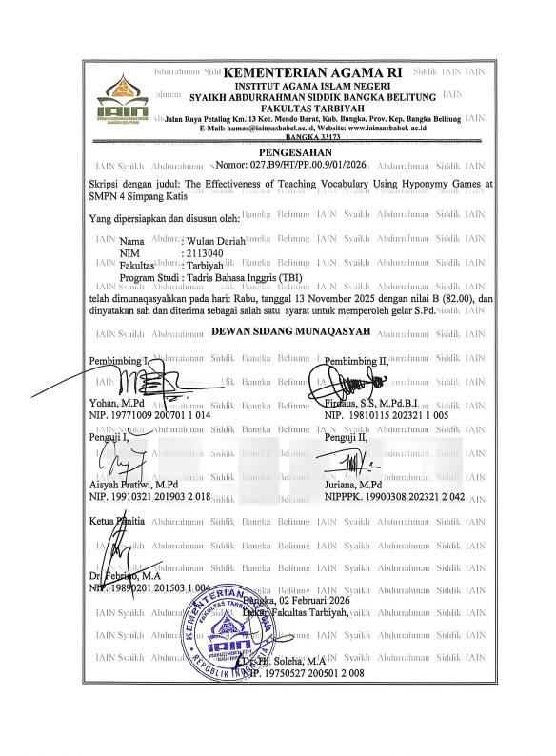

MOTO

“Indeed, Allah Does Not Change the Condition of a People until They Change What Is in Themselves”
(Q.S Ar-Ra`d: 11)

“ Listen! Everyone has their own turn. Be patient and wait, because your turn will come in its own time”
- Gol D. Roger

“ If you don`t take risks, you can`t create a future”
- Monkey D. Luffy

“ If there is no path, then create your own”
- Roronoa Zoro

DEDICATION
Bissmillahirrahmanirrahim….

In the name of Allah SWT, the Greatest, the Most Gracious, and the Most Merciful, who has granted me health and the opportunity to study and complete this thesis. Prayers and salutations are also conveyed to the Prophet Muhammad SAW, who has guided humanity out of the age of ignorance.
As the researcher, I would like to extend my deepest gratitude to all those who have supported and assisted me in this endeavour. My heartfelt thanks go to:
- This work is lovingly dedicated to my beloved parents, Mr. Hasim and Mrs. Sri Sutini, whom I affectionately call Bapak and Mamak. As a symbol of my devotion, respect, and deepest gratitude, I dedicate this humble work to both of you who have given me endless love, care, prayers, and support. Your sacrifices and sincerity have been my greatest strength throughout every step of my journey. May this small achievement be the beginning of my effort to bring happiness to you, for I realize that I have not yet done much to repay all your kindness. To my dearest parents, thank you for always motivating me, showering me with love, guiding me with patience, and never ceasing to pray for my success. May Allah always bless Bapak dan Mamak with good health, long life, and everlasting happiness.
- For my older brothers, Ali Nurdin and Nur Khozin and my older sister Penti Maya Sari. Thank you for the support, love and strength for me. Your advice, care, and prayers have been the light guiding my steps to this point.
- To the honorable thesis advisors, Mr. Dr. Yohan, M.Pd, as the first advisor and Mr. Firdaus S.S.M.Pd.BI as the second advisor. Thank you very much for your advice and patience in guiding me to complete this thesis. From both of you, I learned a lot about how to do research. May Allah always protect and give happiness to you both.
- To all the lectures in the English Education Study Program, thank you so much for the knowledge you have given me. May Allah always protect you and your families.
- To a friend like a sister, Junisa and Miranti. Thank you for being a part of my journey, for contributing by making time for me. thank you very much for helping me to finish this thesis. You guys help me a lot through all of the hard times. You guys never complain when i ask too many question. I will forever grateful for thta. Thank you so much.
- To all my friends who have been with me and whose names I cannot mention one by one. Thank you for every memory and for the support given during the process of composing this thesis. Your presence in my life provided ample motivation to keep moving forward and evolving into a person who understands experience, maturation, patience.
- For my classmates (TBI B 2021). Thank you very much for always being together in the ups and downs. We have always supported each other all this time. Much love from me.
- For all Teachers in SMP Negeri 4 Simpang Katis, thank you very much you always help me whenever I need anything to finish this thesis and you also give me inspiration and motivation to become a good teacher in the future.
- To all students of SMP Negeri 4 Simpang Katis, especially VIIA and VII D, thank you very much for allowing me to do research there and supporting me in completing this thesis

THE EFFECTIVENESS OF TEACHING VOCABULARY USING HYPONYMY GAMES AT SMPN 4 SIMPANG KATIS

Wulan Dariah
2113040
Tarbiyah Faculty
English Education Study Program
State Institute of Islamic Studies
Syaikh Abdurrahman Siddik
Bangka Belitung

Abstract

This study aimed to discover whether there was a significant difference in students’ vocabulary mastery who were taught using the Hyponymy Game and those who were not taught using hyponymy game at the seventh grade of SMP Negeri 4 Simpang Katis. The researcher used a quantitative method with a quasi-experimental design. The population of this research was all seventh-grade students, and the sample consisted of 60 students divided into two groups, namely 30 students as the experimental group and 30 students as the control group. The data were collected through vocabulary tests, observation, and documentation. Based on the results of statistical analysis, it was found that there was an improvement in the students’ vocabulary mastery taught using the Hyponymy Game. The average score of the experimental group’s pre-test was 59.833 and the post-test was 79.917, while in the control group, the pre-test average was 51.673 and the post-test was 74.500. The data were analyzed using the Independent Sample T-test. The result showed that the mean post-test score of the experimental group was higher than that of the control group, with the Sig. (2-tailed) value of 0.001, the degree of freedom (df) of 58, and the t-obtained value of 3.655 which was higher than the t-table value of 2.000 at the significance level of 0.05. Therefore, the null hypothesis (Ho) was rejected, and the alternative hypothesis (Ha) was accepted. It can be concluded that the Hyponymy Game is effective in improving students’ vocabulary mastery.

Keywords: Hyponymy Game, Vocabulary Mastery, English learning.

ACKNOWLEDGMENT
First of all, I would like to express my endless gratitude for what Allah SWT for providing the opportunity to complete this thesis, entitled “The Effectiveness Of Teaching Vocabularu Using Hyponymy Games At SMP Negeri 4 Simpang Katis”. This thesis fulfills the academic requirements for a Bachelor’s degree (S.Pd) in English Language Studies at the State Islamic Institute Syaikh Abdurrahman Siddik Bangka Belitung. The research was conducted from August to September 2025 at SMP Negeri 4 Simpang Katis. furthermore, the researcher would like to express her deepest gratitude to:
- Rector of IAIN SAS Bangka Belitung, Dr. Irawan, M.S.I.
- The Dean of Tarbiyah Faculty, Dr. Hj. Soleha, M.A
- The Head of English Education Study Program, Ihda Husnayaini, M.Pd.
- The Academic Advisor, Firdaus S.S. M.Pd.BI
- The First Advisor, Dr, Yohan, M.Pd.
- The Second Advisor, Firdaus S.S. M.Pd.BI
- All lectures of English Education Study Program.
- The Principal, teachers, and staff of SMP Negeri 4 Simpang Katis
- All the seventh-grade students of SMP Negeri 4 Simpang Katis.
Kace, 22 October 2025

The Researcher

Wulan Dariah
21113040

TABLE OF CONTENTS

LETTER OF DECLARATION i
OFFICIAL MEMO OF ADVISORS ii
OFFICIAL MEMO OF ADVISORS iii
DEDICATION iv
ACKNOWLEDGMENT vii
MOTO viii
TABLE OF CONTENTS ix
LIST OF TABLES xi
Abstract xii
CHAPTER I 1
INTRODUCTION 1
A. Background of Study 1
B. The Limitations of Study 6
C. The Problems of The Study 6
D. The Objectives of Study 6
E. Significances of the Study 7
F. Previous Related Studies 7
G. Structure of the Study 13
CHAPTER II 15
THEORITICAL FRAMEWORK 15
A. Vocabulary Mastery 15
B. Kinds Of Vocabulary 16
C. The Important of Vocabulary 18
D. Teaching of Vocabulary 19
E. Definition of Game Error! Bookmark not defined.
F. Definition of Hyponymy 26
G. Teaching Vocabulary by Using Hyponymy Game 28
H. Procedure of Teaching Vocabulary Using Hyponymy 30
I. Hypothesis of Study 30
CHAPTER III 32
RESEARCH METHOD 32
A. Research Design 32
B. The Setting of the Research 33
C. Population and Sampel 34
D. The Technique of Collecting Data 36
E. The Technique Analyzing Data 39
CHAPTER IV 44
FINDING AND INTERPRETATIONS 44
A. Findings of the Research 44
B. Interpretation of the Study 87
CHAPTER V 93
CONCLUSIONS AND SUGGESTIONS 93
A. CONCLUSION 93
B. SUGGESTIONS 94
REFERENCES 96
DOCUMENTATIONS E-48

LIST OF TABLES

Tabel 1.1 Score Preliminary 3
Tabel 3.1 Design of Reseacrh 33
Tabel 3.2 The Population of the Research 34
Tabel 3.3 The Sample of the Research 35
Tabel 3.4 The Result of Validity Test 41
Tabel 3.5 The Result of the Reability Test 42
Tabel 4.1 Paired Sample Statistics in Experimental Group 77
Tabel 4.2 Paired Sample Correlations in Experimental Group 78
Tabel 4.3 Paired Sample T-test in Experimental Group 78
Tabel 4.4 Paired Saample Statistics in Control Group 79
Tabel 4.5 Paired Sample Correlations in Control Group 79
Tabel 4.6 Paired Sample T-test in Control Group 80
Tabel 4.7 Group Statistics Independent Sample T-test of Students Pre-Test 80
Tabel 4.8 Independent Sample T-test of Students Pre-Test 80
Tabel 4.9 Group Statistics Independent Sample T-test of Students Post-test 81
Tabel 4.10 Indenpendent Sample T-test of Students Post-test 82
Tabel 4.11 The Result of Observation in Experimental Group 83
Tabel 4.12 The Result of Observatio in Control Group 83

